As of this week, all fully vaccinated 18 + individuals are eligible for a COVID Booster!!!

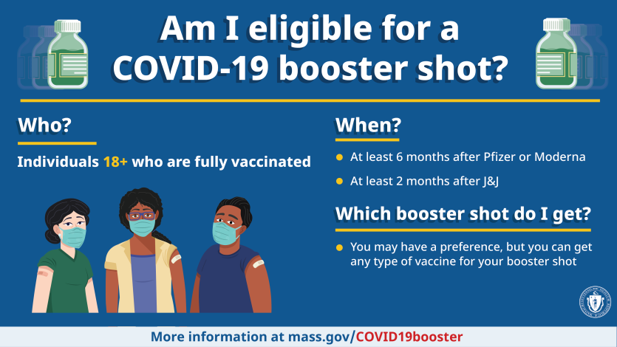

Reminder about Test and Stay:
Per DESE, only in-school close contacts are eligible to Test and Stay. If you are notified that your child was identified as a close contact outside of the school setting, then your child must stay home and follow the quarantine protocol. Please inform the school nurse in order to discuss a safe return to school plan.

Travel info:
The current state travel information defers to the CDC travel recommendations. Check the state website regularly in case there are any updates. Have a safe and Happy Thanksgiving Break next week!
For Domestic Travel, the information in the following chart is what is recommended (there are NO requirements in the chart):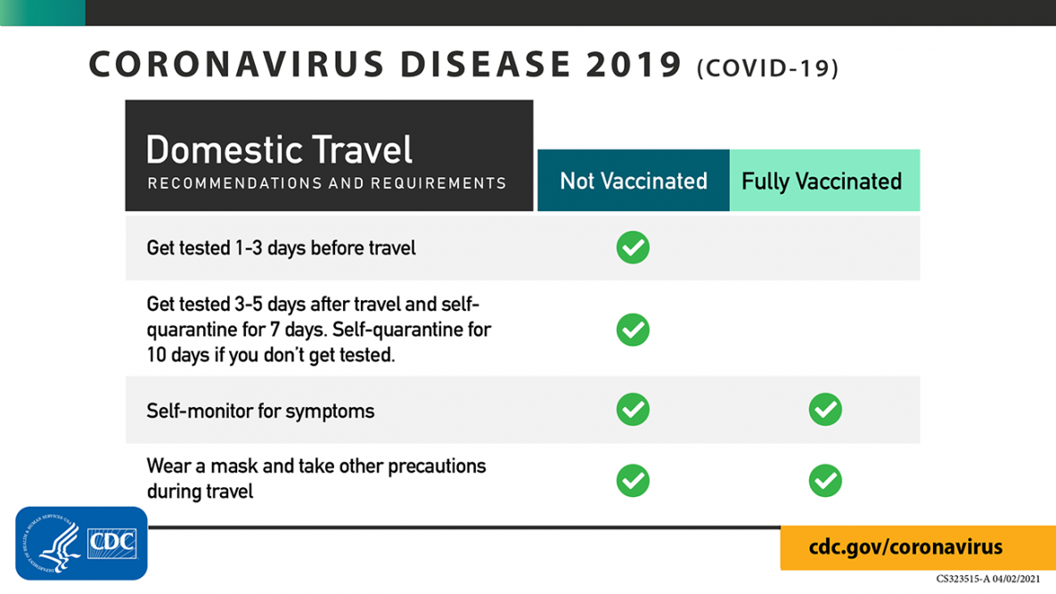
For International Travel:
Make sure to plan ahead before traveling internationally:
- Check the current COVID-19 situation at your destination.
- Follow all airline requirements as well as any requirements at your destination, including mask wearing, proof of vaccination, testing, or quarantine. Requirements may differ from U.S. requirements.
RECOMMENDED: If you are not fully vaccinated, get tested with a viral test 1-3 days before your trip.
Before Returning to the United States:
Testing - ALL Travelers (REQUIRED)
Before boarding a flight to the United States, you are required to show one of the following:
- If you are fully vaccinated: Proof of vaccination and a negative COVID-19 test result taken no more than 3 days before travel.
- If you are NOT fully vaccinated: A negative COVID-19 test result taken no more than 1 day before travel.
- Children under 2 years old do not need to test. There is also an option for people who have documented recovery from COVID-19 in the past 90 days. Learn more about these requirements.
After Arrival in the United States:
You might have been exposed to COVID-19 on your travels. You might feel well and not have any symptoms, but you can still be infected and spread the virus to others. For this reason, CDC recommends the following:
ALL Travelers
RECOMMENDED
- Get tested with a COVID-19 viral test 3-5 days after travel.
  - Find a U.S. COVID-19 testing location near you.external icon
- Self-monitor for COVID-19 symptoms; isolate and get tested if you develop symptoms.
- Follow all state and local recommendations or requirements after travel.
If You Are NOT Fully Vaccinated
RECOMMENDED
In addition to the testing recommendations above
- Stay home and self-quarantine for a full 7 days after travel, even if you test negative at 3-5 days.
- If you don’t get tested, stay home and self-quarantine for 10 days after travel.

If Your Test Result is Positive
Isolate yourself to protect others from getting infected. Learn what to do and when it is safe to be around others.
Just a reminder- If your student is sick, please keep them home. Call the school nurse at 978-952-2555 x3 to report illness and receive guidance.

